Nueces County Community Action Agency
Employee Direct Deposit Enrollment Form

To enroll in Direct Deposit, simply fill out this form and give to Human Resources. Attach a voided check for each checking account - not a deposit slip or a signed form from your bank institution. If depositing to a savings account, ask your bank to give you the Routing/Transit Number for your account. It isn’t always the same as the number on a savings deposit slip. This will help ensure that you are paid correctly. Changes will not be made without supporting documentation.

Below is a sample check MICR line, detailing where the information necessary to complete his form can be found.
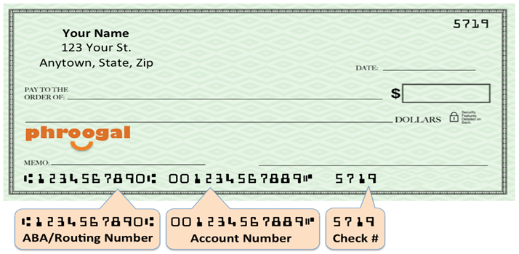

IMPORTANT! Please read and sign before completing and submitting.
I hereby authorize NCCAA to deposit any amounts owed me, as instructed by my employer, by initiating credit entries to my account at the financial institution (hereinafter “Bank”) indicated on this form. Further, I authorize Bank to accept and to credit any credit entries indicated by NCCAA to my account. In the even that NCCAA deposits funds erroneously into my account, I authorize NCCAA to debit my account for an amount not to exceed the original amount of the erroneous credit.

This authorization is to remain in full force and effect until NCCAA and Bank have received written notice from me of its termination in such time and in such manner as to afford NCCAA and Bank reasonable opportunity to act on it.

Employee Name: Employee ID: __________________

Employee Signature: Date:

Account Information

The last item must be for the remaining amount owed to you. To distribute to more accounts, please complete another form.

Make sure to indicate what kind of account, along with amount to be deposited, if less than your total net paycheck.

Bank Name/City/State: ____________________________________________________________________

Routing Transit #:

Account Number:

Checking Savings Other I wish to deposit: $ .

Or Entire Net Amount

Bank Name/City/State: ____________________________________________________________________

Routing Transit #:

Account Number:

Checking Savings Other I wish to deposit: $ .

Or Entire Net Amount

